DIFFERENT.ORG PROJECT MANDATE

Context
Different.org is a crowdfunding platform that is owned and operated by Different Life (Pty) Ltd. All funds donated to NGO projects via Different.org are channelled through Different Foundation (RF) NPC, which serves the purpose of conduit for funds donated to other section 18A-exempt NGOs. For the sake of simplicity, in the context of the NGO application process, we will refer to Different.org as the implementing entity, while Different Foundation shall be the entity dictating the applicable vision and values.

How it works
If you would like to apply to have your NGO project on Different.org, please consider the following information, to ensure that your application meets the requirements.

There are four steps in the NGO application process:
- Step 1: Assessment of applicant NGO’s alignment with Different.org objectives;
- Step 2: Assessment of applicant NGO’s governance and capacity;
- Step 3: Final approval of the application;
- Step 4: Agreement on project deliverables.

Step 1: Assessment of applicant NGO’s alignment with Different.org objectives
Following an initial expression of interest by the NGO, alignment with the following is considered.

Mission. Different Foundation aims to maximise impact in South Africa by supporting and mobilising funds for charitable organizations making a positive impact in South Africa.

Scope of activities. Different Foundation aims to maximise impact in South Africa by supporting organisations whose activities fall within one or more of the following categories:
1. Education;
2. Environmental Care;
3. Health Care;
4. Job Development;
5. Poverty Alleviation.

Objectives. A further consideration regarding Different Foundation’s mission to maximise impact is that it aims to promote a society which values compassion, upholds justice and seeks to empower its members in a manner which enables them to sustain themselves (in a holistic manner). This will also be borne in mind when determining whether an organisation is compatible with the Different Foundation and its mission.

Furthermore, if the applicant’s activities address one or more of the objectives above, does the project seek to promote sustainability and self-sufficiency?

Exclusions. Any organisations whose objectives, functions and activities fall within the following criteria are precluded:
1. Projects falling outside of South Africa;
2. Proselytizing;
3. Building projects for structures whose primary purpose is a religious place of worship;
4. Projects which would be contrary to the interests of the Different Group and/or have a conflict of interest;
5. Organisations not upholding respectful behaviour as determined by Different Foundation.

Step 2: Assessment of applicant NGO’s governance and capacity
The NGO is asked to supply the following documents, which are then reviewed:
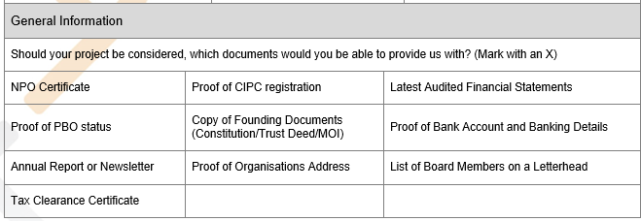
The applicant is also asked whether or not it or any of the organisation's directors, officers, employees or volunteer staff, government or political officials? If yes, then details are requested.

Step 3: Final approval of the application
In some cases, especially with larger target funding amounts, project approval may be at the discretion of the Different Foundation board.

Step 4: Agreement on project deliverables
Following successful completion of steps 1 and 2, a Memorandum of Understanding (MOU) between Different Life (Pty) Ltd (owner and operator of Different.org), and the NGO, is drawn. This sets out expectations and deliverables between the parties.

The following needs to be established:
Expectations. Does the applicant understand and appreciate what is expected of it by the Different Foundation?
Capacity. Does the applicant have the capacity to deliver as expected?
Intention. Does the applicant agree that it will meet these expectations?
Agreement. Is the applicant in agreement with the type and nature of assistance to be given by the Different Foundation in its undertaking to maximise impact?
Collaboration. Is the applicant aware of the nature of the partnership between itself and Different.org – and that this is not merely a grant, but rather, a collaborative effort?

The following parameters are applicable to NGO projects on Different.org:
- Thresholds for project funding target amounts: (1) minimum: R15 000; (2) maximum: R250 000.
- All projects need to fall within at least one of the five project categories.
- The project projected impact needs to score at least 50/100 on the Different Foundation Impact Metrics system.
- 100% of the project funding target amount must be applied to the project as described in the MOU. Failure to do so without prior discussion and mutual agreement, in writing, will lead to retraction of funds.

